12/18/2024

**Name: Ahmad Kaleem Bhatti**

**Roll ID: 242820**

**Class: BSCSev-F-24**

**Section: A**

Functional English

Report Writing

**Q: Write a report on this chart.**

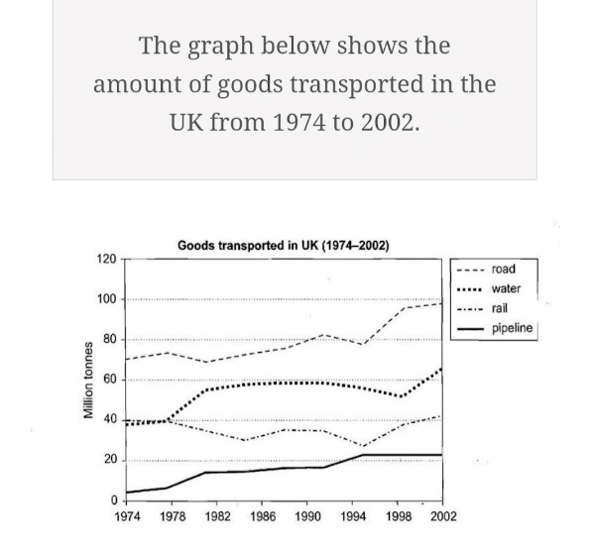

**Answer:**

The line paragraph illustrates the amount of goods transported in the UK from 1947 to 2002 using 4 different modes of transport including roads, water, rail and pipeline. The data is measured in millions of tonnes.

Overall road was the most used method of transportation throughout the period the amount of goods transported by roads increased gradually. Goods transported by water also increased slightly over time. The increase was TD but slower compared to road transport. The use of rail to transport goods decreased slightly over the period due to increase of transport from road. The pipeline transport started at low level there was a gradual increase after sometime. After this, it remains mostly stable.

These goods are measured in million tonnes the amount of goods transported by road increased from 70 million turns in 1947 to 100 million tonnes in 2002. The transport of goods through water started at around 40 million tonnes in 1947 and reached 65 million tonnes by 2002. the use of rail to transport goods started at about 14 million tonnes in 1947 but rail to below 40 million strengths by 2002. The pipeline transport started at 5 million tons in 1947 and increase 220 million tonnes in 1990. After that it remain stable until 2002.

The line graph chooses that road transport was the most popular method and increased the most water transport also grew by time while rail transport decreases gradually five-line transport showed slow growth.